Snape Wood Primary and Nursery School Nursery School



Achievement Summary 2016-17

*(Provisional (Unvalidated)-September 2017)*

**SNAPE WOOD - KEY STAGE 2 DATA (UNVALIDATED)**

Key Stage 2 results does not include a 3% adjustment as 3 pupils who arrived in the UK less than 2 years before the end of Year 6 will not be included in the school’s validated data. This is pending the decision from the DFE.

**Key Stage 2 Results**

**Expected Standard**

|  |  |  |  |  |  |  |  |  |  |  |  |
| --- | --- | --- | --- | --- | --- | --- | --- | --- | --- | --- | --- |
|  | **Reading** | | | **Writing** | | **Grammar** | | | **Maths** | | |
|  | **School** | **National** | | **School** | **National** | **School** | **National** | | **School** | | **National** |
| **EXS**  **2016** | 35% | 66% | | 57% | 74% | 78% | 72% | | 78% | | 70% |
| **Gap** | -31% | | | -17% | | +0.6% | | | +0.8% | | |
| **EXS**  **2017** | 61% | | 71% | 64% | 76% | 71% | | 77% | 61% | 75% | |
| **Gap** | -10% | | | -12% | | -0.6% | | | -14% | | |

**High Score**

|  |  |  |  |  |  |  |  |  |  |  |  |
| --- | --- | --- | --- | --- | --- | --- | --- | --- | --- | --- | --- |
|  | **Reading** | | | **Writing** | | **Grammar** | | | **Maths** | | |
|  | **School** | **National** | | **School** | **National** | **School** | **National** | | **School** | | **National** |
| **High**  **2016** | 0% | 19% | | 0% | 15% | 9% | 22% | | 9% | | 17% |
| **Gap** | -19% | | | -15% | | -13% | | | -8% | | |
| **High**  **2017** | 7% | | 25% | 7% | 18% | 29% | | 31% | 11% | 23% | |
| **Gap** | -18% | | | -11% | | -2% | | | -12% | | |

**Reading, Writing and Maths Combined KS2**

|  |  |  |
| --- | --- | --- |
|  | **Expected or Above** | **High** |
| **School 2016** | 22% | 0% |
| **National 2016** | 53% | 5% |
| **Gap 2016** | -31% | -5% |
| **School 2017** | 43% | 0% |
| **National 2017** | 61% | 9% |
| **Gap 2017** | 18% | -9% |

**Average Scaled Score KS2**

|  |  |  |  |
| --- | --- | --- | --- |
|  | **Reading** | **Grammar** | **Mathematics** |
| **National 2016** | 103 | 104 | 103 |
| **School 2016** | 98.2 | 104 | 105 |
| **National 2017** | 104 | 106 | 104 |
| **School 2017** | 99.7 | 105 | 101 |
| **Gap** | -4.3 | -1.0 | -3.0 |

**Key Stage 1 Results**

**Expected Standard**

|  |  |  |  |  |  |  |  |  |
| --- | --- | --- | --- | --- | --- | --- | --- | --- |
|  | **Reading** | | | **Writing** | | **Maths** | | |
|  | **School** | **National** | | **School** | **National** | **School** | | **National** |
| **EXS**  **2016** | 57% | 74% | | 60% | 65% | 63% | | 73% |
| **Gap** | -17% | | | -5% | | -20% | | |
| **EXS**  **2017** | 68% | | 74% | 67% | 69% | 63% | 75% | |
| **Gap** | -6% | | | -2% | | -12% | | |

**Greater Depth**

|  |  |  |  |  |  |  |  |  |
| --- | --- | --- | --- | --- | --- | --- | --- | --- |
|  | **Reading** | | | **Writing** | | **Maths** | | |
|  | **School** | **National** | | **School** | **National** | **School** | | **National** |
| **GDS**  **2016** | 3% | 24% | | 0% | 13% | 3% | | 18% |
| **Gap** | -21% | | | -13% | | -15% | | |
| **GDS**  **2017** | 8% | | 25% | 0% | 16% | 8% | 21% | |
| **Gap** | -17% | | | -16% | | -13% | | |

**Reading, Writing and Maths Combined KS1**

|  |  |  |
| --- | --- | --- |
|  | **Expected or Above** | **High** |
| **School 2016** | 46% | 0% |
| **National 2016** | 60% | 9% |
| **Gap 2016** | -14% | -9% |
| **School 2017** | 58% | 0% |
| **National 2017** | 64% | 11% |
| **Gap 2017** | -6% | -11% |

**Year 1 Phonics Screening Check**

|  |  |  |  |
| --- | --- | --- | --- |
|  | **% at expected level 2015** | **% at expected level 2016** | **% at expected level 2016** |
| **School** | 50% | 63% | 70% |
| **National** | 77% | 81% | 81% |
| **Gap** | -27% | -18% | -11% |

**EYFS Year on Year Data**

|  |  |  |  |
| --- | --- | --- | --- |
|  | **GLD 2015** | **GLD 2016** | **GLD 2017** |
| **School** | 42% | 62% | 77% |
| **National** | 66% | 69% | 71% |
| **Gap** | -23% | -7% | -6% |
| **LA** | 58% | 64% | 66% |
| **Gap** | -16 | -2 | -11% |

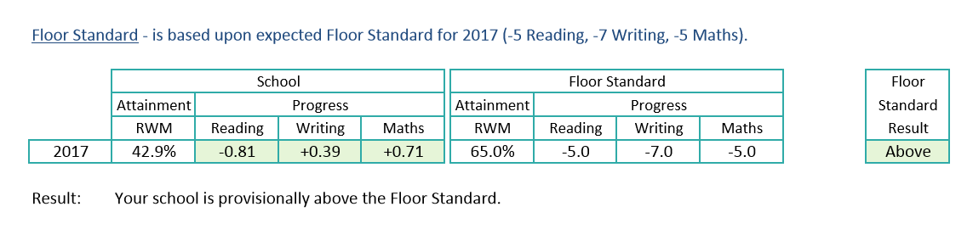

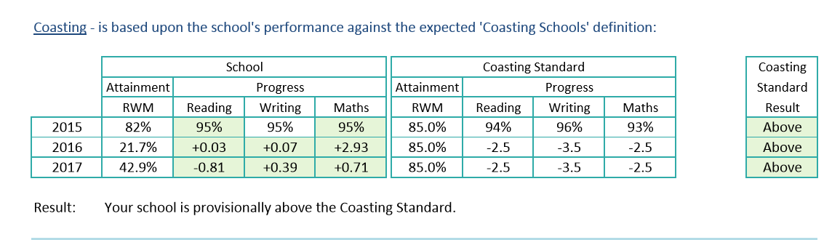

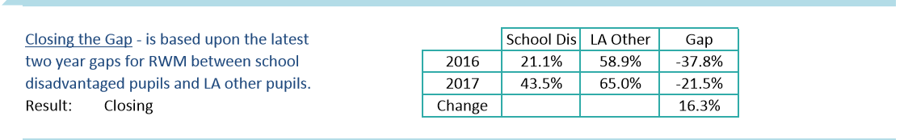

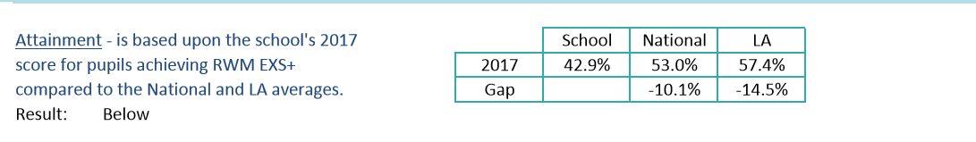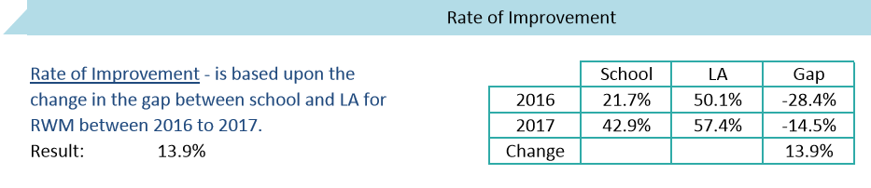

**DIMINISHING THE DIFFERENCE**

**END OF EYFS RESULTS 2017**

|  |  |  |  |  |
| --- | --- | --- | --- | --- |
| **SUBJECT** | **ALL PUPILS 2016** | **DISADVANTAGED 2016** | **ALL PUPILS 2017** | **DISADVANTAGED 2017** |
| **GLD** | **58%** | **70%** | **71%** | **83%** |

**END OF KS1 RESULTS 2017**

|  |  |  |  |  |
| --- | --- | --- | --- | --- |
| **SUBJECT** | **ALL PUPILS 2016** | **DISADVANTAGED 2016** | **ALL PUPILS 2017** | **DISADVANTAGED 2017** |
| **READING** | **64%** | **53%** | **71%** | **65%** |
| **WRITING** | **64%** | **58%** | **71%** | **65%** |
| **MATHS** | **64%** | **64%** | **71%** | **59%** |
| **RWM COMBINED** | **55%** | **42%** | **71%** | **53%** |

**END OF KS2 RESULTS 2017**

|  |  |  |  |  |
| --- | --- | --- | --- | --- |
| **SUBJECT** | **ALL PUPILS 2016** | **DISADVANTAGED 2016** | **ALL PUPILS 2017** | **DISADVANTAGED 2017** |
| **READING** | **50%** | **32%** | **40%** | **65%** |
| **WRITING** | **75%** | **53%** | **40%** | **70%** |
| **MATHS** | **50%** | **84%** | **40%** | **65%** |
| **RWM COMBINED** | **21%** | **25%** | **40%** | **44%** |

**PHONICS**

|  |  |  |  |  |
| --- | --- | --- | --- | --- |
| **SUBJECT** | **ALL PUPILS 2016** | **DISADVANTAGED 2016** | **ALL PUPILS 2017** | **DISADVANTAGED 2017** |
| **YEAR 1** | **25%** | **30%** | **27%** | **32%** |
| **YEAR 2** | **40%** | **60%** | **0%** | **57%** |