his is still conditional, and the reopening of

schools will only happen if the five key tests set out by the government have been met.



**Snape Wood Primary and Nursery School**

**Aspen Road**

**Bulwell**

**Nottingham**

**NG6 7DS**

**Telephone: 0115 9159146**

**E-mail: admin@snapewood.nottingham.sch.uk**

**Head Teacher: Mrs S Choudhury (B.Ed. Hons)**

**Chair of Governors: Mrs C Cotterill**

Friday 28th August 2020

Dear Parents/Carers

We hope that you have had a lovely summer spending time with loved ones. We are excited and cannot wait to receive the Y2 children on Thursday 3rd September. Y2 staff will be Miss Tellier and Miss Koulouri.

**Entrance:** Y2 will enter through the Aspen Road entrance at 8:45 am – usual gate. Children must arrive on time. If your child is late, they will have to go to the front office and wait to be collected – please use the main entrance of the school if you arrive after 9:00am.

**Exit:** Y2 will leave school via the Toybox entrance on Aspen Road at 3:05pm. Please make sure that you are on the same roadside as the school when collecting your child. We will not release children if parent/carers are across the road, due to health and safety. Parents will wait outside the gate. Children will be released to parents. Please ensure that you are on time to avoid impacting on other bubbles. If your child is walking home, you must notify the school prior to your child starting school.

* Only 1 adult to drop off per child
* If your child is walking to school, then please notify the office of your intention.
* No parents permitted onto school site unless emergency
* Chd must wear school uniform, sun cream, labelled hat and water bottle every day. Children may wear trainers. That are black and unbranded
* Children do not need to bring anything into school. All equipment will be provided.

**Time Slot:** Please see the times for each bubble.

Y2 BUBBLE: 08:45 – 15:05

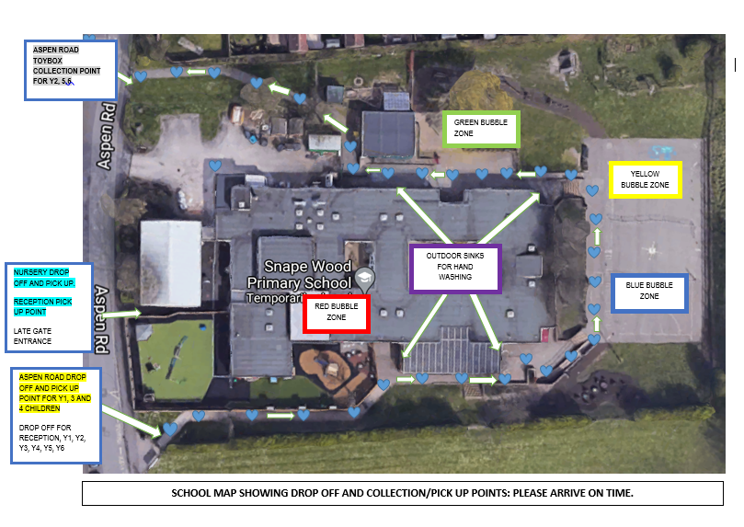

These plans are subject to Local Authority and Government change. Please keep checking your emails and websites for any updates. **IMPORTANT:** if your child is displaying Covid-19 symptoms, please do not bring them to school. If you live with an adult who is in the ‘High risk’ category, it is recommended that your child does not attend school.

Children staying at home: if you have decided to keep your child at home, please collect a home learning pack by informing the office of when you intend to collect, or continue with online learning on the website.

If you have any questions, please contact school by phoning 0115 9159146 or email: [admin@snapewood.nottingham.sch.uk](mailto:admin@snapewood.nottingham.sch.uk)

Please take care and keep safe.

Mrs Shewley Choudhury

Headteacher